LAB-7 SERVER AND SERVICE
OUPUTS:
WEB SERVER USING IP:

172.16.0.10
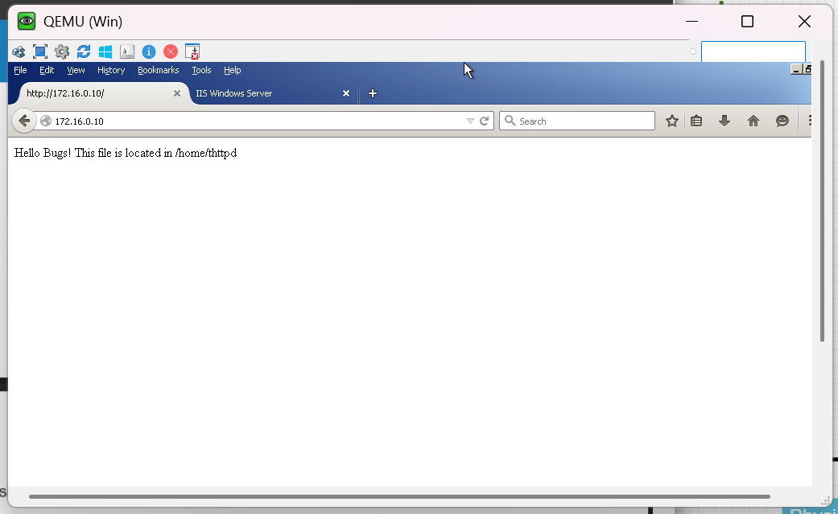

172.16.0.20
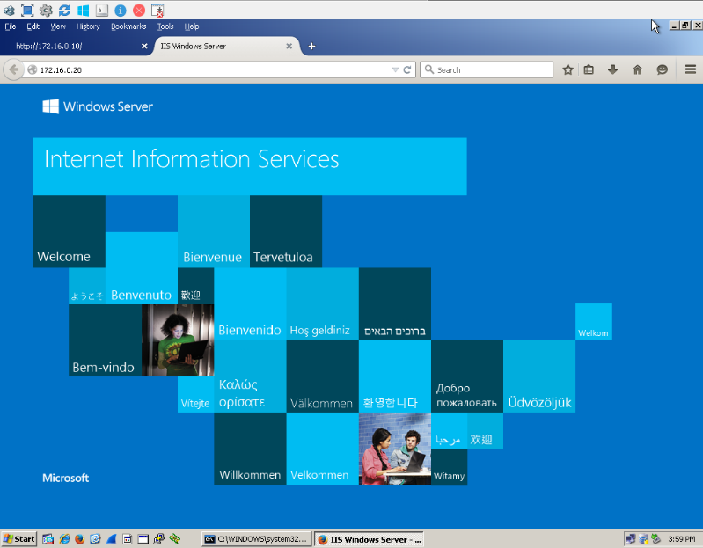

OUTPUTS:
WEB SERVER USING DNS
WWW.HOTDTAR.COM 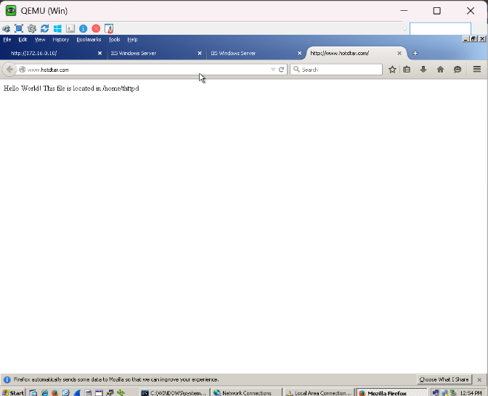

WWW.NETFLIX.IN

